

**Appendix 2 Dual-purpose Travel Calculator**



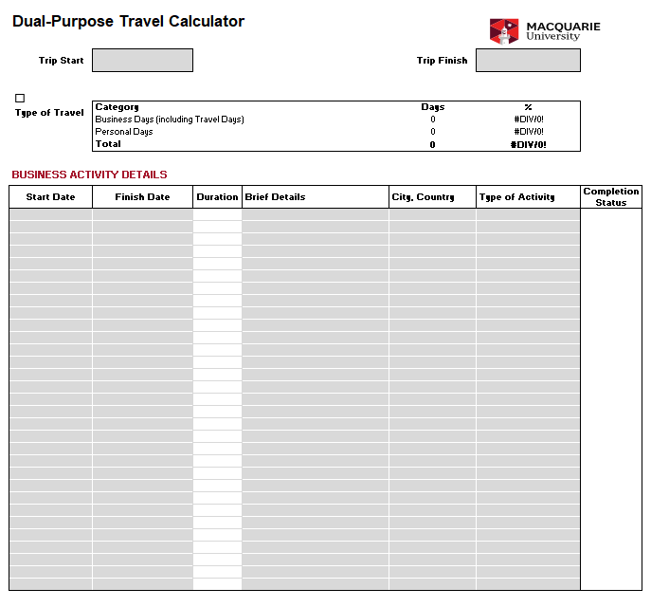

**Example 1**

Total number of travel days: 9

Total number of Personal Days: 4

Total number of Business Days: 5

Personal Days are less than the Business Days portion, therefore travel is not classified as Dual-Purpose and 100% of the airfare is paid by the University.

|  |  |  |  |
| --- | --- | --- | --- |
| **Date** | **Day** | **Category** | **Activity** |
| 1/9 | Thursday | P | Personal Day |
| 2/9 | Friday | P | Personal Day |
| 3/9 | Saturday | P | Personal Day |
| 4/9 | Sunday | P | Personal Day |
| 5/9 | Monday | B | Business Day |
| 6/9 | Tuesday | B | Business Day |
| 7/9 | Wednesday | B | Business Day |
| 8/9 | Thursday | B | Business Day |
| 9/9 | Friday | B | Business Day |

**Example 2**

Total number of travel days: 10

Total number of Personal Day: 5

Total number of Business Days: 5

Personal Days are equal to or greater than the Business Days; therefore, travel is classified as Dual Purpose and 50% of the airfare is paid by the Traveller to the Travel Management Company at the time of booking, a Travel Diary must be completed.

|  |  |  |  |
| --- | --- | --- | --- |
| **Date** | **Day** | **Category** | **Activity** |
| 1/10 | Thursday | P | Personal Day |
| 2/10 | Friday | P | Personal Day |
| 3/10 | Saturday | p | Personal Day |
| 4/10 | Sunday | p | Personal Day |
| 5/10 | Monday | p | Personal Day |
| 6/10 | Tuesday | B | Business Day |
| 7/10 | Wednesday | B | Business Day |
| 8/10 | Thursday | B | Business Day |
| 9/10 | Friday | B | Business Day |
| 10/10 | Saturday | B | Business Day |