

# **Disability Action Plan 2012 - 2017**

“Full and effective participation and inclusion in society….”

UN Convention on the Rights of Persons with Disabilities, 2008

This Plan was developed by the Equity and Diversity Unit (Social Inclusion).

Thank you to the Steering Committee, and to all the staff and students who so graciously gave of their time, their experience and their expertise in the development of this first Disability Action Plan for Macquarie University.



T: (02) 9850 7471

E: [equityanddiversity@mq.edu.au](mailto:equityanddiversity@mq.edu.au)

Endorsed February 2012

PHOTO CREDITS

F J Gaylor, p. 6, 17, 36; Phillipa Janos, p. 15, 16; Paul Wright Photography, p.26.

# Foreword

I am delighted to present to you Macquarie University’s first Disability Action Plan 2012 - 2017.

Macquarie University has a strong commitment to equity and inclusion, and it is this commitment that has driven the development and implementation of the Macquarie University Disability Action Plan.

Although the University has for many years had programs and services to support access and successful participation of staff and students with disability, it has not previously coordinated these through one Plan. The adoption of this Plan is an important step in improving coordination of service provision and communication between disability stakeholders, service providers and University management.

The Plan captures what Macquarie University is doing well in disability access and service provision, priority areas for improvement, the actions required to reach our goals, and who will assume responsibility for its implementation. It aligns with and reflects the University’s strategic vision.

The Disability Action Plan is drawn from and reflects the University’s values and aspirations to be:

* Ethical
* Enquiring
* Creative
* Inclusive
* Responsive
* Excellent

****These values are reflected in the Plan’s goals and actions. It aims to be responsive to the needs of all people with disability; to find creative solutions and best practice approaches to tackle barriers to access and participation; and to provide a welcoming and inclusive campus where the dignity and worth of each person is respected, and everyone has the opportunity to flourish.

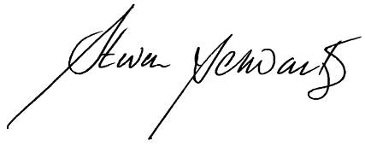

Professor Steven Schwartz, Vice Chancellor

Contents

Foreword 3

Contents 4

Legislative Framework 5

UN Convention on the Rights of Persons with Disabilities 5

Federal and State Legislation 5

Standards and Guidelines 5

Definition of disability 6

Obligations under the Disability Discrimination Act 7

Development of the Macquarie Disability Action Plan 8

Disability Data 8

People with Disability at Macquarie: a Snapshot 9

Implementation, Monitoring and Evaluation 11

Communication and promotion of the Disability Action Plan 11

Summary of DAP Priority Areas and Goals 12

DAP Priority Areas: Executive Responsibility and Actions 14

Priority Area 1: University Governance, Planning and Policy 14

Priority Area 2: Learning, Teaching and Research 16

Priority Area 3: Access to Information and Communications 25

Priority Area 4: Inclusive Physical Environment 29

Priority Area 5: Employment and Professional Development 31

Priority Area 6: Campus Community 33

Appendices/Statistics 37

Disability at Macquarie: a STUDENT Snapshot 37

People with Disability at Macquarie: a STAFF Snapshot 40

# Legislative Framework

## UN Convention on the Rights of Persons with Disabilities

The United Nations’ *Convention on the Rights of Persons with Disabilities* entered into force in May 2008. The Convention promotes, protects and ensures the full enjoyment of all human rights and fundamental freedoms of people with disability, and aims to promote recognition of their inherent dignity. The Convention recognises people with disability as the world’s largest minority, comprising around 10% of the global population. Australian data suggest that over 18% of Australians live with a disability. Australia is a signatory to both the Convention and the Optional Protocol (enabling Australians to make complaints to the United Nations Disabilities Committee in the event that all domestic remedies have been exhausted). Article 24 of the Convention relates to education, and commits signatories to ensure that education is fully accessible to people with disability and enables people with disability to achieve their full potential.

## Federal and State Legislation

This Disability Action Plan has been developed in compliance with the requirements of the *Commonwealth Disability Discrimination Act 1992 (DDA) as amended January 2010,* the *NSW Anti-Discrimination Act 1977,* and also reflects requirements for employers detailed in the *Fair Work Act 2009.* Under the DDA, organisations can develop a Disability Action Plan as a proactive approach to achieving compliance with the Disability Discrimination Act. A Disability Action Plan assists an organisation to identify its strengths in access and service provision for people with disability, and to address areas identified for improvement in a phased and coordinated manner. This Plan has been forwarded to the Australian Human Rights Commission (HRC) pursuant to section 67 of the DDA and will be made available to the public through the HRC website.

## Standards and Guidelines

The DDA gives the Federal Government the power to make Disability Standards in particular areas such as education. The Australian Disability Standards for Education 2005 (currently under review) provide a more detailed specification of the rights of people with disability and the responsibilities of education and training providers in relation to equal access and opportunity for people with disability to education. The Standards give students and prospective students with disability the right to education and training opportunities on the same basis as students without disability. This includes the right to comparable access, services and facilities, and the right to participate in education and training without discrimination. Education providers have a positive obligation to make reasonable adjustments according to the needs of students with disability.

Further, Universities Australia is currently listing the Australian Vice-Chancellors Committee (AVCC) Guidelines relating to Students with a Disability May 2006 as a document to assist universities in their efforts to meet their obligations under the legislation listed above. These standards and guidelines have also been taken into account in the preparation of this Plan.Definition of disability

The definition of disability used here is as per the *Commonwealth Disability Discrimination Act 1992*. The Act is administered by the Federal Attorney-General's Department and takes into account amendments up to *Acts Interpretation Amendment Act 2011*. The definition of disability was amended in 2008 to include a genetic predisposition to disability.

*Disability*, in relation to a person, means:

* total or partial loss of the person's bodily or mental functions; or
* total or partial loss of a part of the body; or
* the presence in the body of organisms causing disease or illness; or
* the presence in the body of organisms capable of causing disease or illness; or
* the malfunction, malformation or disfigurement of a part of the person's body; or
* a disorder or malfunction that results in the person learning differently from a person without the disorder or malfunction; or
* a disorder, illness or disease that affects a person's thought processes, perception of reality, emotions or judgment or that results in disturbed behaviour;

and includes a disability that:

* presently exists; or
* previously existed but no longer exists; or
* may exist in the future (including because of a genetic predisposition to that disability) ; or
* is imputed to a person.

To avoid doubt, a *disability* that is otherwise covered by this definition includes behaviour that is a symptom or manifestation of the disability.

# Campus courtyard. Reference FJG-MQ-4409.jpgObligations under the Disability Discrimination Act

(DDA) with regard to Education[1]

People with disability have a right to study at any educational institution in the same way as any other person. This includes all public and private educational institutions, primary and secondary schools, and tertiary institutions such as TAFE, private colleges and universities. The DDA makes it illegal for a university to discriminate because a person has disability.

Educators must offer a person with disability the same educational opportunities as everyone else. This means that if a person with disability meets the necessary entry requirements they must have the same opportunity to study there as anyone else. Educators must base their decisions on a person's ability to meet the essential requirements of the course, and should not make assumptions about what a person can or cannot do because of disability.

The DDA protects people with disability against discrimination in education in the following areas:

**Admission**: including refusal or failure to accept an application for admission from a person with disability; or accepting a person with disability as a student on less favourable terms or conditions than others, eg asking a person with disability to pay higher fees.

**Access**: including denying or limiting access to people with disability eg not allowing them to attend excursions or join in activities; delivering lectures in an inaccessible format, or having inaccessible common rooms; expelling a person because of a disability, or subjecting a person with a disability to any other detriment.

**Harassment**: including humiliating comments or actions about a person's disability, such as insults, or comments or actions which create a hostile environment.

### Reasonable Adjustments

If a person with disability meets the essential entry requirements, then educators must make changes or "reasonable adjustments" if that person needs them to perform essential coursework. An example would be if a student is not able to perform dissections in a biology course because the bench is too high. The ability to reach a certain height is not an essential part of dissection. The student would be perfectly capable of performing the tasks of the lab session if provided with a lower table. In most situations the person with disability will be able to tell educators what they need to be able to perform essential coursework.

Adjustments could include:

* Modifying educational premises eg making ramps, modifying toilets and ensuring that classes are held in accessible rooms.
* Modifying or providing equipment eg lowering lab benches, enlarging computer screens, providing specific computer software or an audio loop system.
* Changing assessment procedures eg allowing alternative methods such as oral exams or additional time.
* Changing course delivery eg providing study notes or research materials in different formats or providing a sign language interpreter for a deaf person.

The DDA does not require changes to be made if this will cause major difficulties or unreasonable costs to a person or organisation. This is called "unjustifiable hardship". If adjustments are refused because they do cause hardship, the education provider must show that the hardship is unjustified.

# Development of the Macquarie Disability Action Plan

The Plan has been developed to be:

**Inclusive** Core activities of the University are designed and implemented in order to accommodate the needs of all students, staff and visitors with disability

**Comprehensive** Provisions for people with disability cover all university activities in recognition of their right to participate fully in the academic and social life of the University

**Equitable** The University responds to and recognises the needs, rights and responsibilities of all stakeholders and ensures that solutions are equitable for all concerned

**Explicit** Policies clearly identify student and staff responsibilities in relation to the provision of services and adjustments, the procedures whereby these will be implemented and the mechanisms for resolving disagreements

**Systemic** Consideration of the needs of the diverse student and staff populations is embedded within University-wide planning, administrative support and quality assurance processes

**Respectful** Interactions with people with disability are characterised by respect for their rights to dignity, privacy and confidentiality

**Consultative** Students and staff are engaged in planning, review and evaluation of disability-related strategies

Resourced University management provides adequate resources to enable implementation of the Plan

## Disability Data

In the 2009 Australian Bureau of Statistics (ABS) Survey of Disability, Ageing and Carers, four million people in Australia reported a disability. The prevalence of disability in 2009 was 18.5%, 1.5% lower than when the survey was previously conducted in 2003. Much of this decrease was attributed to a decline in the proportion of Australians disabled by physical health conditions, such as asthma and heart disease. Of those with a reported disability, 87% had a specific impairment restricting their ability to perform communication, mobility or self-care activities, or a restriction associated with schooling or employment.

Respondents with disability aged 15-64 years were 21.6% less likely to have completed year 12 than people without disability, and 9.7% less likely to have completed a bachelors degree or higher qualification. The labour force participation rate of people with disability was 54.3% and the unemployment rate was 7.8%. The corresponding rates for those without disability were 82.8% and 5.1%.

The median gross personal income per week of people aged 15-64 years with a reported disability was 56% of those without disability.

This data demonstrates that having disability remains a persistent barrier to education, employment and life opportunities.

## People with Disability at Macquarie: a Snapshot

### Students at Macquarie

The number of students registering with the Macquarie Disability Service each year has almost doubled since 2007, with 947 students registered in 2011 (up from 435 in 2007).

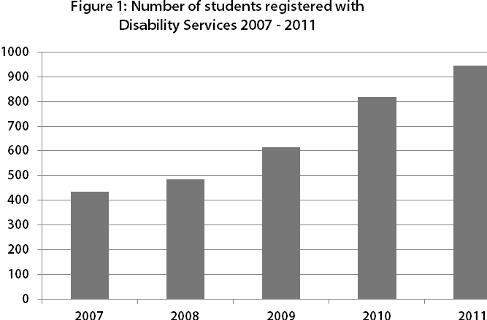

Mental health issues, chronic medical and learning disability are the areas increasingly presenting for assistance through the Service. Students with Mental Health issues registering at the Service are the fastest growing cohort (up from 91 in 2007 to 298 in 2011). This cohort is the largest by number and the most complex and resource intensive group to support. Campus Wellbeing have drafted a Mental Health Strategic Plan which will address both students and staff issues and align with the Disability Action Plan. It is notable that the Disability Service saw no comparable increase in the incidence of other disability types over the same time period (see Appendices: Table 3).

The highest percentage of students with disability within the University are in the Faculty of Arts (4.8%) and Human Sciences (4.4%) and the lowest is in MGSM (0.6%).

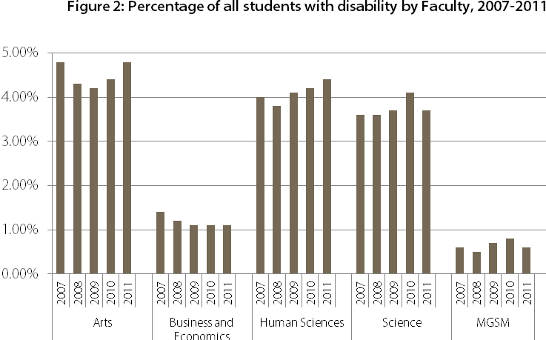

Fifty-five percent of students presenting to the Macquarie Disability Service are female, 30% are male and 15% did not specify their gender in 2011. There has been a significant increase in the number of students of ‘unspecified’ gender presenting to the Macquarie Disability Service since 2007.

### Staff at Macquarie

The NSW government benchmark for the employment of people with disability requiring workplace adjustments is 1.2% in 2012 and 1.3% in 2013.

At Macquarie, information regarding staff with disability is gathered through voluntary completion of the online equal opportunity (EO) survey instrument on the Human Resources Information System (HRIS) with approximately 60% of staff providing this information as at March 2011.

The overall percentage for people with disability employed at Macquarie as at 31 March 2011 was 4.4%. The University is below the benchmarks for the employment of people with disability in both academic and professional positions. In 2011 academic staff with disability were 4.7% of the academic staff respondees; and professional staff with disability were 4.2% of the professional staff respondees.

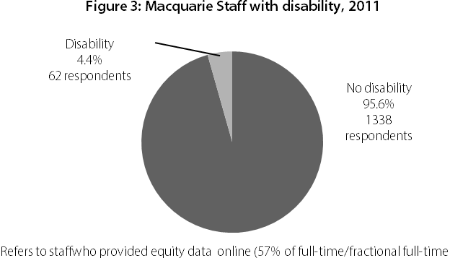

Between 2006 and 2010, the highest representation of people with disability in the academic workforce who responded to the survey was 6.3% in 2007; and for professional staff 7.4% in 2006. Increasing the representation of people with disability in the Macquarie workforce has been identified as a priority in this Disability Action Plan.

Strengthening data collection on staff with disability (quantitative and qualitative) has also been identified as a priority, for example, gathering data on disability types for staff and establishing mechanisms for consultation.

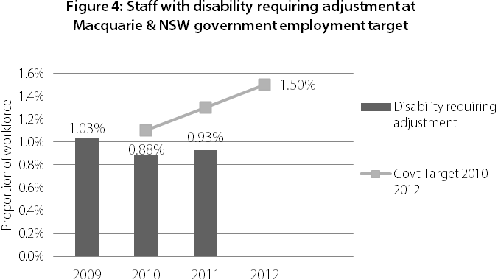

## Implementation, Monitoring and Evaluation

The six priority areas identified in the Disability Action Plan (DAP) are critical to achieving an improved and equitable experience for people with disability studying or working at Macquarie. These priority areas are not mutually exclusive and progress in each will have implications across all others. Success indicators for each priority area are identified, and nominated key stakeholders have agreed to be responsible for the coordination and outcomes of actions within the 5 year life span of the DAP (with a mid-term review). Areas that will assist in the implementation have been identified as appropriate. Careful consideration will be given to the roll out and resourcing of the respective actions to ensure that the identified goals can be achieved. A mid- term review will be conducted in 2014 with a fuller evaluation in the final year of the DAP to inform the subsequent Plan.

Oversight of the DAP will be through the Social Inclusion portfolio within the Office of the Deputy Vice Chancellor and Provost at Macquarie.

A Disability Action Plan Reference Group (DAPR) will report directly to the Pro Vice Chancellor Social Inclusion. Membership will be broad and include those with key responsibilities under the DAP and stakeholders such as Senior Managers, Deans/Directors, and staff and students with disability. The DAPR will prioritise the Actions of the DAP and assist Faculties and Offices to develop local action plans based on the DAP, local data, needs and experience. The DAPR will coordinate, support and monitor the implementation of the Plan, oversee the mid-term review and act as a resource and clearinghouse for disability issues at Macquarie for the 5 year duration of the DAP.

## Communication and promotion of the Disability Action Plan

It is imperative that all staff and students of Macquarie are aware of the Disability Action Plan and know their rights and responsibilities in relation to it. The DAP will be available on the Macquarie website and widely disseminated across the University. It will be available in accessible format in hard and electronic versions, and lodged with the Australian Human Rights Commission.

The Macquarie University DAP 2012 - 2017 will be:

* referred to in enrolment and Human Resources information
* accessible and available in a range of formats (PDF, RTF, hard copy in standard and large print, Braille, CD, electronically accessible and uploaded to the Macquarie website)
* linked to relevant websites including Policy Central and Social Inclusion
* lodged with the Australian Human Rights Commission and uploaded to their website
* promoted to students through Campus Life, Macquarie University Student Representative Association (MUSRA) and Postgraduate Association (MUPRA), student newsletter Grapeshot and broadcast email
* promoted to staff through an MQ Announcement, Launch event, Staff News, face to face meetings
* referred to as part of the Memorandum of Understanding with CRS Australia in work placement negotiations at Macquarie for people with disability
* a summary version will be available and promoted in staff and student orientation, induction, professional development programs, and at events eg Open Day and Parent Nights
* Equity and Diversity staff will refer to the DAP in presentations across campus on equity related topics eg grievance management, bullying and harassment
* hard copies will be distributed across the University including to Faculties, Offices and Affiliates
* updates and related achievements of the DAP will be periodically promoted to the University community
* detailed implementation plans will be developed for areas with specific responsibilities; with support available through DAPR, the Equity and Diversity Unit and the Disability Service
* affiliated bodies will be contacted and encouraged to align their activities with the University’s DAP.

# Summary of DAP Priority Areas and Goals

**1. University Governance, Planning and Policy**

* 1. Institutional strategic planning will consider implications for people with disability, support inclusion in education, research and employment; and acknowledge the university’s legal and social obligations.
  2. Local strategic and operational planning (aligned with institutional strategic planning) will be directly informed by the Disability Action Plan.
  3. All governance, planning and policy development will be underpinned by the principle of consultation with people with disability.
  4. Policy will be monitored through University governance and continuous improvement processes in relation to all aspects of campus life for people with disability.
  5. Policy documentation (including policies, procedures, guidelines and schedules) will be inclusive and fully accessible to people with disability.

**2. Learning, Teaching and Research**

* 1. Aspiration, Outreach and Recruitment: Students with disability will view Macquarie as the university of choice for their education.
  2. Enrolment, Transition and Induction: Students with disability will experience accessible enrolment and a smooth transition to and through university.
  3. The Learning, Teaching and Research Experience:

1. Macquarie learning, teaching and research environments will allow equitable participation by students with disability
2. Academic staff will be knowledgeable, confident and capable in addressing the learning needs of students with disability. Academic staff will develop and embed inclusive practices into their learning, teaching and research
3. Professional staff will be knowledgeable, confident and capable in responding to the needs of students with disability, including accuracy and excellence in service provision
4. All Macquarie staff will be able to reflect on their practice and sensitively, efficiently and effectively manage day to day issues for students with disability from a duty of care perspective.
   1. Participation, Retention and Success
5. Reasonable adjustments required to ensure equity of access to success will enable full participation of students with disability, and will be implemented in a timely manner
6. A culture of consultation and continuous improvement of inclusive learning, teaching and research for people with disability will become normal practice at Macquarie
7. HDR students with disability will be supported in their post graduate experience
8. Disability-awareness and competency will be investigated as a possible Graduate Attribute
9. Graduating students with disability will be actively supported and encouraged to gain employment commensurate with their education and experience.
   1. Inclusive Curricula: Learning, teaching and research design and materials will be accessible and equitable for students with disability.
   2. Assessment and Exam Provisions / Special Consideration: The assessment of courses will be inclusive and enable students with disability to equitably demonstrate the achievement of learning outcomes.
   3. Participation Units, Fieldwork and Overseas Study Placements
10. Students with disability will be able to participate in learning environments on and off campus
11. Overseas study opportunities will be available for students with disability and will allow participation.

**3. Access to Information and Communications**

* 1. Information and Communication Technologies (ICT) and multimedia learning experiences and environments will offer equitable access and participation for students and staff with disability.
  2. ICT systems (including data management systems) will be fully accessible for students and staff using text to speech technologies eg JAWS, WYNN.
  3. Library ICT services will be fully accessible to students, staff and visitors with disability and commensurate with international best practice.
  4. Information published by the University is designed using Universal design principles and will be fully accessible to people with disability.
  5. Right to privacy for students and staff with disability will be protected in all systems.
  6. Consultation mechanisms will be in place with people with disability, with ICT ‘user friendliness’ and stakeholder satisfaction monitored.

**4. Inclusive Physical Environment**

* 1. Macquarie University will aspire to become a best practice model of an inclusive built environment, based on universal design principles.
  2. Macquarie University will aim to develop a physically ‘connected’ campus with identifiable improvements in physical accessibility for people with disability to, from and around campus, through evidence based research and identified funded priorities.
  3. Institutional capacity regarding inclusive physical environment will become strong through the establishment of an Accessible Environments Advisory Group with an accompanying policy schedule to formally address physical access issues and enable communication and consultation with staff and student stakeholders.
  4. Staff and contractors will be aware of their responsibilities regarding the provision of a safe and inclusive physical environment for people with disability.

**5. Employment and Professional Development**

* 1. Through an articulated Disability Employment Strategy, Macquarie University will aim to increase the number of people with disability employed by the University in accordance with the recommended government targets.
  2. Mechanisms for identifying and matching candidates with disability with vacancies at the University will be improved and streamlined.
  3. Human Resource systems will be improved in order to gather robust data to increase knowledge of the Macquarie workforce profile in relation to staff with disability.
  4. Macquarie employment related policy schedules (including advancement strategies such as reclassifications, promotion and professional development) will be continuously improved to ensure all are equitable, accessible and inclusive for existing and prospective employees with disability.
  5. The capacity of all staff will be strengthened in the area of disability (confidence and competence).

**6. Campus Community**

* 1. The University will continue to foster an inclusive campus culture where staff and students are aware, sensitive and responsive to the needs of people with disability, and where diversity is valued and celebrated, and where discrimination and harassment are not tolerated.
  2. The non-academic environment of the University will be inclusive and enable the equitable participation of people with disability.
  3. University facilities and services will be accessible for people with disability and will fully support their participation and usage.

# DAP Priority Areas: Executive Responsibility and Actions

## Priority Area 1: University Governance, Planning and Policy

***EXECUTIVE RESPONSIBILTY Office of the DVC and Provost -*** *Manager, Policy Unit;* ***Deans/Directors;***

***Senior Management Group***

***ASSISTING*** *Director, Equity and Diversity Unit*

Goal 1.1: Institutional strategic planning will consider implications for people with disability, support inclusion in education, research and employment; and acknowledge the university’s legal and social obligations.

**Actions**

* + 1. Embed the principle of inclusion in all relevant Macquarie University strategic plans and key operational plans such as:
* Academic Plan
* Social Inclusion Plan
* Indigenous Advancement Strategy / Research Plan
* Campus Wellbeing and Support strategy
* PACE (Participation and Community Engagement) Strategy
* Macquarie Scholarship Strategy
* Human Resources - Recruitment, Workforce Planning, Staff Health
* Marketing and Communications Plans
* Macquarie Property Plan, Major & Minor Works, Refurbishment Plans
* Information Technology Strategy.

Goal 1.2: Local strategic and operational planning (which aligns with institutional strategic planning) will be directly informed by the Disability Action Plan.

**Actions**

* + 1. Develop local (Faculty/Office) Disability Action Plans to address local issues.
    2. Provide local (Faculty/ Office) with robust disability data to inform practice.
    3. Assist Macquarie staff and students who are responsible for the development of strategic and operational plans to formally consider the DAP in their deliberations and report progress to the Disability Action Plan Reference Group (DAPR).

Goal 1.3: All governance, planning and policy development will be underpinned, inter alia, by the principle of consultation with people with disability.

**Actions**

* + 1. Establish robust consultation and feedback mechanisms with people with disability which become usual practice in strategic planning and policy development.
    2. List all policies in development (or under review) on the Policy Central website and actively encourage feedback from people with disability.

Goal 1.4: Policy will be monitored through University governance and continuous improvement processes in relation to all aspects of campus life for people with disability.

**Actions**

* + 1. Continue the Director of Equity and Diversity or nominee as a member of the University Policy Reference Group.

Goal 1.5: Policy Documentation (includes policies, procedures, guidelines and schedules) will be inclusive and fully accessible to people with disability.

**Actions**

* + 1. Monitor all university policy documentation for accessibility; and if inaccessibility arises, address in timely manner.

SUCCESS INDICATORS University Governance, Planning and Policy

1. All institutional plans (including local operational and strategic plans) reference the DAP and the university’s commitment to inclusion.
2. Local Disability Action Plans are developed (informed by robust data) and demonstrate outcomes aligned with the goals of the DAP.
3. The DAP will be linked through to Policy Central and all policy documentation and systems are checked and meet accessibility best practice before dissemination.
4. Disability considerations are embedded in existing and new policies.
5. Robust data collection, consultation and feedback mechanisms are in place including:

* annual consultations with students and staff with disability
* bi-annual data on students with disability by Department and Units
* annual reporting of numbers of students with disability selecting Macquarie as first choice
* graduate destination outcomes for students with disability.

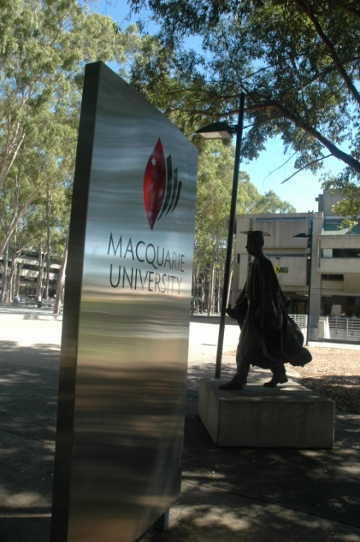

## Priority Area 2: Learning, Teaching and Research

Goal 2.1: Aspiration, Outreach and Recruitment: students with disability will view Macquarie as the university of choice for their education.

***EXECUTIVE RESPONSIBILITY Office of the DVC and Provost*** *-**PVC (Social Inclusion);* ***Office of the Vice President (International and Strategy)*** *- Director of Marketing*

***ASSISTING*** *Director, Campus Wellbeing and Support; Director, Equity and Diversity; Deans /Heads of Department*

**Actions**

* + 1. Embed disability information and inclusive messages into mainstream marketing materials for undergraduate and postgraduate students.
    2. Incorporate disability support and services information, a range of images, and welcoming messages for prospective students with disability into Macquarie’s promotional materials for prospective students.
    3. Invite current students with disability to participate (eg as guest speakers) in outreach, mentoring and transition programs (on and off campus).
    4. Develop comprehensive information for students with disability and their parents about ‘student’ life eg accessible accommodation, support services, MUSRA, MUPRA, student groups, course and career information including transitions to postgraduate study, scholarships, facilities, the role of Campus Wellbeing and Support, and early registration with disability services, student rights and responsibilities. Upload this to the Future Students page of the Macquarie University website to encourage prospective students with disability.
    5. Disseminate Educational Access Scheme information and Scholarship information to prospective students with disability and their parents.

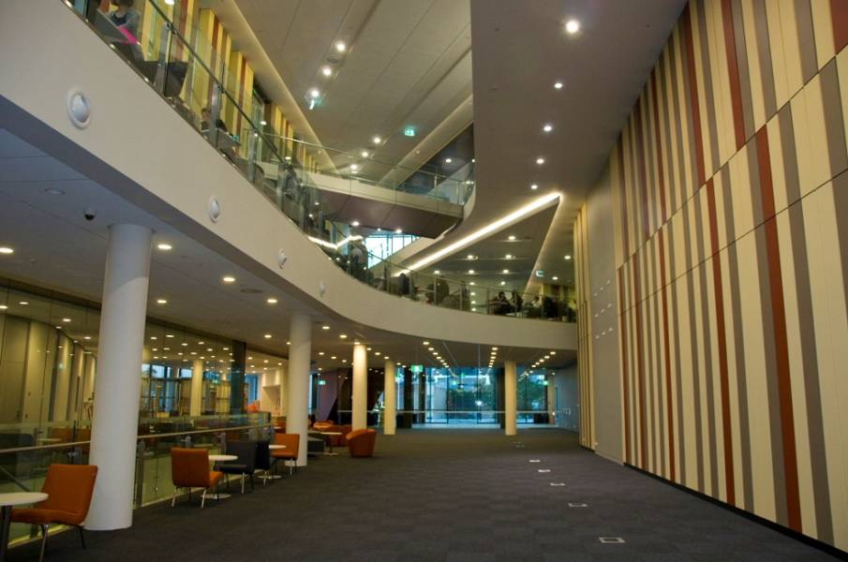

*Macquarie University's Library contains an Automated Retrieval Collection. This is the first of its kind in Australia and has allowed our whole collection to be on site and accessible.*

Goal 2.2: Enrolment, transition and Induction: Students with disability will experience accessible enrolment and a smooth transition to and through university.

***EXECUTIVE RESPONSIBILITY Office of the DVC and Provost*** *–**PVC (Social Inclusion);* ***Office of the DVC (Student and Registrar)***

***ASSISTING*** *Director, Campus Wellbeing and Support; Deans / Heads of Department,; Deputy Registrar*

**Actions**

* + 1. Investigate outreach and access opportunities (with the Department of Education, Employment and Workplace Relations (DEEWR) and NSW Department of Education) to streamline transition and support processes for students with disability from secondary school to university.
    2. Review enrolment processes and procedures (including the Enrolment Day experience) to ensure students with disability are able to participate fully and complete the enrolment process without difficulty and in a timely manner.
    3. Facilitate early enrolment for students with disability to enable timely adjustments to be made.
    4. Identify and address issues for first year students with disability through the Macquarie FYE (First Year Experience) project.
    5. Include information (support and services) available to students with disability in student induction initiatives and processes at all levels (University, Faculty-based, MUSRA, MUPRA, student group representatives).
    6. Investigate processes which would encourage early registration by students with disability with Campus Wellbeing and Support such as the efficacy of the current ‘disability notification’ process on the student enrolment form.
    7. Gather data on the participation of students with disability in various support programs (literacy and numeracy) to inform practice.
    8. Actively encourage students with disability to participate in university wide and Faculty-based transition and induction programs (eg Mentors@Macquarie) and track their participation as mentors and participants.



Goal 2.3: The Learning, Teaching and Research Experience:

* The Macquarie learning, teaching and research environments will allow equitable participation by students with disability.
* Academic staff will be knowledgeable, confident and capable in appropriately addressing the learning needs of students with disability. Academic staff will develop and embed inclusive practices into their learning, teaching and research practice.
* Professional staff will be knowledgeable, confident and capable in responding to the needs of students with disability, including accuracy and excellence in service provision.
* All Macquarie staff will be able to reflect on their practice and sensitively, efficiently and effectively manage day to day issues for students with disability from a duty of care perspective.

***EXECUTIVE RESPONSIBILITY Shared responsibilities monitored by DAP Reference Group***

***ASSISTING*** *Director, Human Resources, Chief Information Officer; Deans/Directors; Director, Learning and Teaching Centre; Manager, Macquarie University Accessibility Services*; *Director, Equity and Diversity Unit; Director, Campus Wellbeing and Support; Manager, Allied Health Services;*

**Actions**

* + 1. Provide relevant professional development to all staff (including sessional academics) on:

1. disability (types, issues, misassumptions, stereotyping, diversity within diversity)
2. support services and appropriate referral (internal and external)
3. inclusive learning and teaching best practice, universal instructional design for all curriculum, front line
4. customer service and appropriate first on scene responses
5. assistive technologies legal responsibilities, Disability Discrimination Act, Disability Standards for Education
6. grievance policy and procedures.
   * 1. Build staff and systems capacity through:
7. integrating guidance on disability issues and inclusive practice in existing professional development initiatives eg staff Induction and Foundations in Learning and Teaching program
8. providing a suite of web-based teaching resources and information on teaching and support strategies, with flexibility and accessibility as core considerations
9. communicating existing strategies (eg available through Macquarie University Accessibility Services, Campus Wellbeing and Support and the Equity and Diversity Unit) which support staff to better understand disability (including physical, sensory, psychological and cognitive) and better support students with disability
10. providing opportunities for academic and professional staff to learn about the lived experience of students with disability in order to develop an appreciation of the complexity of issues, and an awareness of the day to day impact of in/ex-clusive learning and teaching practices
11. encouraging and showcasing best practice through forums such as Learning and Teaching Week, Professional Development Seminars, Equity and Diversity initiatives, Human Resources Organizational Development suite.
    * 1. Provide accurate, timely, relevant and consistent information and services to students with disability throughout their university life (from Faculties, Departments and Offices).
      2. Finalise and roll out the Macquarie Mental Health Awareness Strategy which includes best practice in assisting students.

Goal 2.4: Participation, Retention and Success

1. Reasonable adjustments, required to ensure equity of access to success, will enable full participation of students with disability and be implemented in a timely manner

***EXECUTIVE RESPONSIBILITY Office of the DVC (Students and Registrar)*** *–**Manager Clinical Operations (Disability);**Director****,*** *Campus Wellbeing and Support****;******Office of the DVC (Research) –*** *Dean, Higher Degree Research;* ***Deans/Directors;******Office of the Vice Chancellor*** *(re funding)*

***ASSISTING*** *Director, Learning and Teaching Centre; Director, Equity and Diversity Unit, Manager, Career Development and Employability; Deans/Directors*

**Actions**

* + 1. Ensure reasonable adjustments are assessed by qualified disability services practitioners and are negotiated and implemented by Faculties and Departments through a formal streamlined mechanism.
    2. Clarify roles and responsibilities of staff in relation to reasonable adjustments for students with disability and strengthen communication between staff of Campus Wellbeing and Support and Faculty staff.

Goal 2.4: Participation, Retention and Success continued

1. A culture of consultation and continuous improvement of inclusive learning, teaching and research for people with disability will become normal practice at Macquarie

***EXECUTIVE RESPONSIBILITY Office of the DVC (Students and Registrar)*** *–* ***Manager Allied Health****; Manger Clinical Operations (Disability);* ***Office of the DVC (Research)*** *– Dean, Higher Degree Research;* ***Office of the DVC and Provost*** *–**Deans/ Directors;* ***Office of the******Vice Chancellor*** *(re: funding)*

***ASSISTING*** *Director, Learning and Teaching Centre; Director, Equity and Diversity Unit; Manager, Career Development and Employability; Deans/Directors*

**Actions**

* + 1. Disseminate best practice in service provision to students with disability through strengthening communication channels eg staff networks, collaborations between Learning and Teaching Centre (LTC), Macquarie University Accessibility Services, Equity and Diversity Unit, Campus Wellbeing and Support, Faculties and Offices; conference and seminars presentations to showcase Macquarie achievements.
    2. Continuously improve the collaboration between Campus Wellbeing and Support and Faculties with regard to services for students with disability through:

1. Investigating the need for a bi/tri-lingual Disability Support Officer to work with students with disability from cultural and linguistically diverse backgrounds
2. Providing negotiated, consistent information, communications and processes for supporting students with disability (acquired, permanent, visible, non-visible) across faculties and departments
3. Regularly evaluating and reporting back on service provision
4. Addressing issues of funding of specific student needs (eg undergraduate, higher degree research) in a timely manner.
   * 1. Respond to the increasing enrolments and support needs for Macquarie students with disability studying through Open Universities Australia (in online and external modes)[2].
     2. Recognise that students who have disability are not a homogenous group and as such may require tailored service provision and adjustments eg Indigenous students and those studying on residential mixed mode programs, International students, students from refugee / migrant backgrounds.
     3. Fund Clinical Operations at a rate commensurate with need, considering the increasing number of students with disability requiring assistance.
     4. Review and improve Faculty-based mechanisms for regular consultation with and feedback between staff and students with disability.
     5. Continuously improve the provision of high quality and relevant career development opportunities and advice to students with disability.
     6. Include adaptive technology suppliers / disability employment providers in Macquarie Career Day activities.

Goal 2.4: Participation, Retention and Success continued

1. Higher Degree Research (HDR) students with disability will be supported in their post graduate experience

***EXECUTIVE RESPONSIBILITY Office of the DVC (Students and Registrar)*** *–**Director, Campus Wellbeing and Support;* ***Office of the DVC (Research)*** *– Dean, Higher Degree Research*

***ASSISTING*** *Manager Career Development and Employability; PVC (Social Inclusion)*

**Actions**

* + 1. Actively promote disability support services to HDR students and supervisors, particularly exploring anxiety, isolation and depression.
    2. Investigate whether students with disability perceive there are barriers to pursuing higher degree research at Macquarie, and identify pathways to increase participation of students with disability in higher degree research.
    3. Investigate the possibility of funding carers for HDR students with disability to attend conferences.

Goal 2.4: Participation, Retention and Success continued

1. Disability-awareness and competency will be investigated as a possible Graduate Attribute

***EXECUTIVE RESPONSIBILITY******Office of the DVC and Provost***

***ASSISTING*** *PVC (Social Inclusion)*

**Actions**

* + 1. Investigate the possibility of inclusive practice for people with disability becoming a Graduate Attribute at Macquarie University.

Goal 2.4: Participation, Retention and Success continued

1. Graduating students with disability will be actively supported and encouraged to gain employment commensurate with their education and experience

**EXECUTIVE RESPONSIBILITY Office of the DVC (Students and Registrar)** – Director, Campus Wellbeing and Support; Manager, Career Development and Employability;

***ASSISTING***  *Dean, Higher Degree Research*

**Actions**

* + 1. Actively develop and promote online careers and job search resources for students with disability.
    2. Advise potential employers of graduates of Macquarie’s commitment to providing an inclusive environment for students with disability and encourage them to provide workplace opportunities.
    3. Provide organisational skills coaching/development for Macquarie students who are close to graduation to prepare and empower them for the workplace and to prevent transitional stress.
    4. Monitor graduate outcomes for students with disability and use the data to inform the development of work experience and mentoring opportunities for current students with disability.
    5. Investigate establishing and participating in ‘transition to employment’ programs which offer graduates with disability participation in the workforce eg ‘Stepping into’ programs, CRS direct registration, Alumni initiatives.

Goal 2.5: Inclusive Curricula: Learning, teaching and research design and materials will be accessible and equitable for students with disability including:

* Information (paper based and electronic including course content, materials, unit guides, media)
* Learning Management Systems
* Procedures (at all levels)

***EXECUTIVE RESPONSIBILITY Office of the DVC and Provost –*** *Associate Deans (Learning and Teaching); Director, Learning and Teaching Centre; Manager, Macquarie University Accessibility Services*

***ASSISTING*** *Manager, Allied Health Services; Academic Senate (The Senate Learning and Teaching Committee); Faculty Learning and Teaching Committees*

**Actions**

* + 1. Establish a process to deliver learning and teaching information (course materials, online study guides and electronic media such as podcasts) in accessible formats and include information on how Macquarie actively supports the learning of students with disability.
    2. Develop university-wide, standardised guidelines and procedures to ensure for the conversion of course materials into alternative formats (as required) so that students with disability receive them in a timely manner.
    3. Provide accessible learning management systems for exchange between students; and students and staff.
    4. Ensure processes and procedures relating to learning and teaching at all levels across the University are accessible for students with disability.

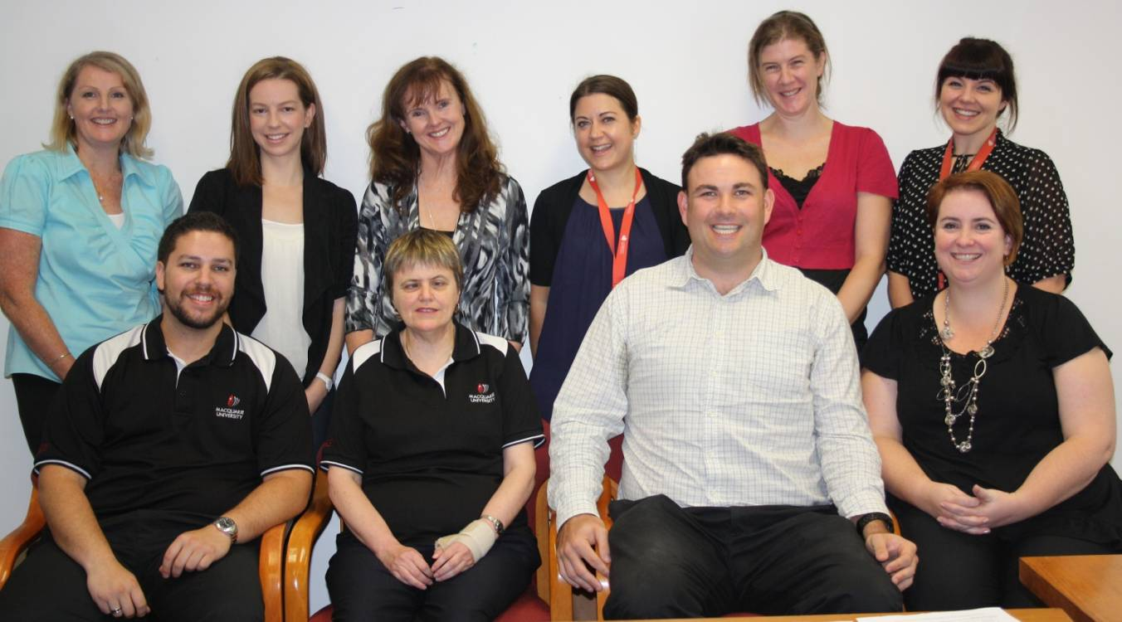

*Clinical Operations (Disability) Team(L-R back row) Vivienne Burridge, Tamara Brkic, Bareena Johnson, Liz Gray, Michelle Corbett, Kelly Piper; (L-R front row) Rob Pereira, Sondra Wibberley, Dr Benjamin Wilkes, Nicole Saunders.*

Goal 2.6: Assessment and Exam Provisions[3] (implementing reasonable adjustments for students with disability):

* The assessment of units is inclusive and enables students with disability to equitably demonstrate the achievement of learning outcomes
* Exam provisions are managed equitably, sensitively and efficiently for students with disability

***EXECUTIVE RESPONSIBILITY Office of the DVC and Provost –*** *Associate Deans (Learning and Teaching);* ***Executive Deans;******Office of the DVC (Students and Registrar)***

***ASSISTING*** *Manager, Allied Health Services; Manager Clinical Operations (Disability)*

**Actions**

Assessment:

* + 1. Provide clear and well-publicised assessment procedures.
    2. Embed flexible assessment practices in assessment design wherever possible.
    3. Articulate the principle of alternative assessment strategies for students with disability in Unit Guides and include the web link to the Macquarie Assessment Policy.
    4. Invite students with disability to comment on their experience with regard to accessibility and inclusive learning and teaching practices in their Unit and Course evaluations. (Investigate the feasibility of including disability specific questions, in addition to the existing open ended questions in Teaching and Evaluation Development Service, Learner Experience of Unit and postgraduate feedback mechanism).
    5. Academics will note in their unit evaluations provisions made for students with disability (either specifically through the Disability Service and/or more generally such as inclusive unit design, delivery and assessment practices).
    6. Establish a process of continuous improvement in learning and teaching delivery to students with disability through feedback that is looped from Associate Deans (Learning and Teaching) to Learning and Teaching Centre (LTC) staff, the Disability Service and where relevant, to the Equity and Diversity Unit [4].

Exam Provisions (delivering reasonable adjustments for students with disability):

* + 1. Provide clear and consistent university wide policies, procedures and guidelines on exam provision with specific responsibilities identified.
    2. Include this information in unit outlines, including a web link.
    3. Ensure staff with key academic advising roles receive communication of the most current information on exam provisions for students with disability.
    4. Continue the centralised system (coordinated through the Academic Programs Section) for final exam provisions for students with disability.
    5. Resolve the resourcing and logistics issues around the provision of timely reasonable adjustments for students with disability for faculty-based mid-semester exams and cumulative class assessments.

Goal 2.7: Participation Units, Fieldwork and Overseas Study Placements:

* Students with disability will be able to participate in learning environments on and off campus
* Overseas study opportunities will be available for students with disability and will allow participation.

***EXECUTIVE RESPONSIBILITY Office of the DVC and Provost*** *–**PVC (Social Inclusion); Academic and Programs Director, PACE*

***ASSISTING*** *Executive Deans; Manager, Student Advocacy and Support; Director, Campus Wellbeing and Support; Director of Marketing; Faculty Academic Directors of Participation; Faculty Participation Managers; Manager, Macquarie University Accessibility Services*

**Actions**

* + 1. Make explicit the inherent requirements of all on and off site participation activities and practical learning placements.
    2. Establish a contingency fund for reasonable adjustments (eg travel, accommodation, equipment) for students with disability (and their carers, when necessary) for on and off site practical learning placements.
    3. Specifically address the needs of students with disability in domestic placement partnership arrangements on a case by case basis.
    4. Develop international partnership agreements that recognise the needs of students with disabilities both generally and on a case by case basis, taking into consideration the capability and infrastructure of the partner organisation.
    5. Ensure all promotional and information packages for on and off site practical learning placements are welcoming for students with disability and have inclusive messages and diverse images.
    6. 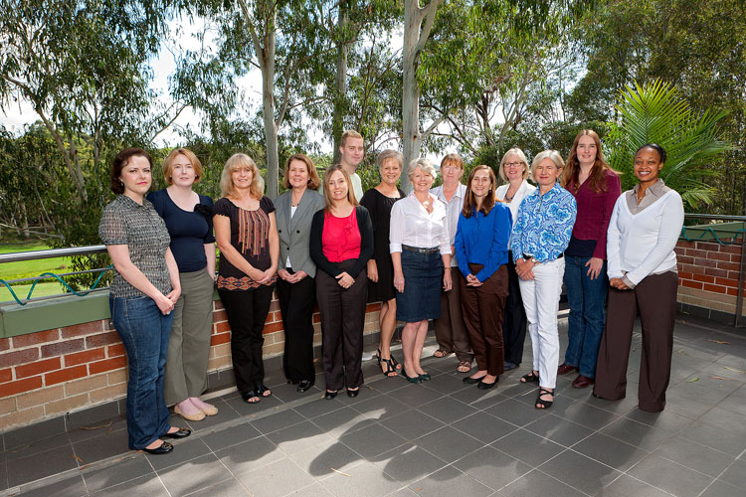Provide ongoing professional development for staff involved in the planning and selection processes for on and off site practical learning placements.

*PACE Team L-R:Diana Caruso, Marie Kelliher, Dr Leanne Carter, Judy Hutchison, Nicole Yeates, Dave Rorke, Jane Worthy, Robyne Spicer, Ruth McHugh, Anne-Louise Semple, Professor Gail Whiteford (PVC Social Inclusion), Lindie Clark (PACE Academic and Programs Director), Dr Michaela Baker, Dr Valentine Mukuria.*

SUCCESS INDICATORS Learning, Teaching and Research

1. Macquarie’s outreach, learning, teaching and promotional materials are accessible and reflect a culture of inclusion for people with disability.
2. Reasonable adjustments for mid-semester exams and class tests are administered smoothly and in a timely manner within faculties.
3. Best practice models and exemplar units using electronically accessible course materials will be developed with each faculty and academic staff will report increased competence and confidence in developing inclusive curricula.
4. Research is conducted to discover what, if any, barriers to higher degree research are perceived by students with disability.
5. Availability of professional development (including web based materials) for all staff on disability awareness, confidence and competence.

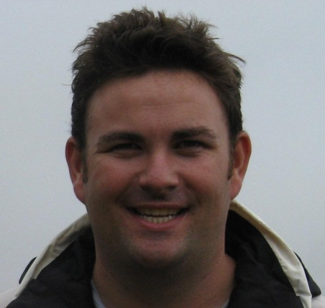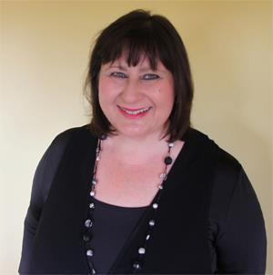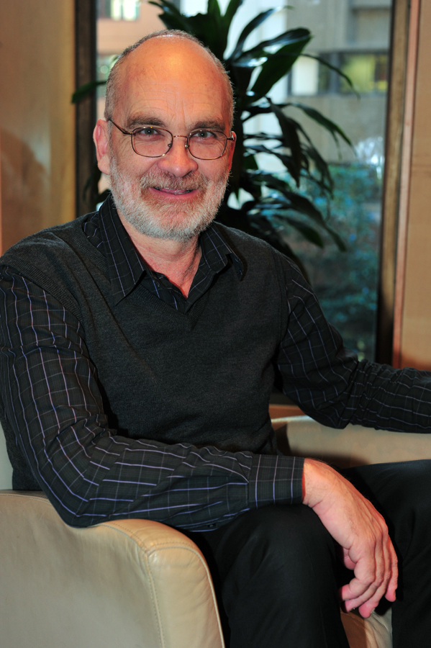

*L-R: Sharon Kerr, Manager, Macquarie University Accessibility Services (MQAS); Steve Bailey, Manager, Allied Health Services & Dr Ben Wilkes, Manager, Clinical Operations, Campus Wellbeing and Support.*

## Priority Area 3: Access to Information and Communications

Goal 3.1: ICT and multimedia learning experiences and environments will offer equitable access and participation for students and staff with disability.

***EXECUTIVE RESPONSIBILITY Office of the DVC and Provost –*** *Manager, Macquarie University Accessibility Services*

***ASSISTING*** *Associate Deans (Learning and Teaching)*

**Actions**

* + 1. Provide academic staff with guidelines, professional development opportunities and ongoing support from qualified education developers to assist in the provision of accessible learning materials prior to inclusion in the Learning Management System.
    2. Introduce quality control measures for faculties to ensure all online curricula are fully accessible.
    3. Develop guidelines for academic staff on the appropriate use of accessible ICT by students with disability.
    4. Provide appropriate and timely support for students using assistive technology.
    5. Regularly review and upgrade assistive technology resources.

Goal 3.2: ICT systems (including data management systems) will be fully accessible for students and staff using text to speech technologies eg JAWS, WYNN

***EXECUTIVE RESPONSIBILITY*** ***Office of the DVC and Chief Operating Officer*** *– Chief Information Officer* ***Office of the DVC and Provost*** *– University Librarian;* ***Office of the DVC (Students and Registrar)*** *–**Director, Campus Wellbeing and Support*

***ASSISTING*** *Manager, Macquarie University Accessibility Services;*

**Actions**

* + 1. Assess all proposed online systems for accessibility, including user testing, prior to purchase by the university.
    2. Provide comprehensive user testing which reflects the diversity of disability support needs in the staff and student population eg visual, hearing, mobility etc.
    3. Assess existing systems for accessibility at the point of upgrade or change (establish regular front end and review processes).
    4. Build responsibility for universal design expertise and systems assessing into the position description of a qualified responsible officer in Informatics.
    5. Provide accessibility user testing of Macquarie systems to address the needs of students engaged in fully online learning modes (via OUA or off campus/ distance education programs) from point of enquiry, to website navigation, to applications, receiving an offer, enrolling, studying and communicating with academic staff through to graduation.

Systems include:

* University website and Policy Central
* Student Information Systems
* Learning management systems (eg iLearn)
* Online enrolment
* Units
* Moodle
* Library Retrieval
* Human Resources systems (Information and recruitment)
* Finance and accounting systems
* Electronic help desks for various applications eg OneHelp
* Staff professional development online suite, materials eg Organisation and Staff Development; OHS training.

Goal 3.3: Library and ICT services will be fully accessible to students, staff and visitors with disability and commensurate with international best practice.

***EXECUTIVE RESPONSIBILITY Office of the DVC and Provost*** *– University Librarian;* ***Office of the DVC (Students and Registrar)*** *–**Director, Campus Wellbeing and Support;* ***Office of the DVC and Chief Operating Officer*** *– Chief Information Officer*

***ASSISTING*** *Manager, Macquarie University Accessibility Services*

**Actions**

* + 1. Provide qualified and readily available assistance in the Library to students and staff with disability (disability liaison officer or similar) to provide appropriate services and referral.
    2. Continue to provide assistance and alternative access to Library resources to students and staff with disability (including databases, third party databases and print resources) and provide students with clear information about where and how to obtain assistance.
    3. Increase the capacity of Informatics staff (primarily HelpDesk shift supervisors) in the use of assistive technologies and knowledge of the accessibility guidelines.
    4. Provide resourced and managed study areas (and assistive technology) for students with disability in the Library and across campus, which prevent the segregation and isolation of students with disability.
    5. Disseminate the details of these allocated study areas (location and resources available) to students with disability and also to prospective students with disability.
    6. Provide equity of access to ICT on campus for students with disability.
    7. 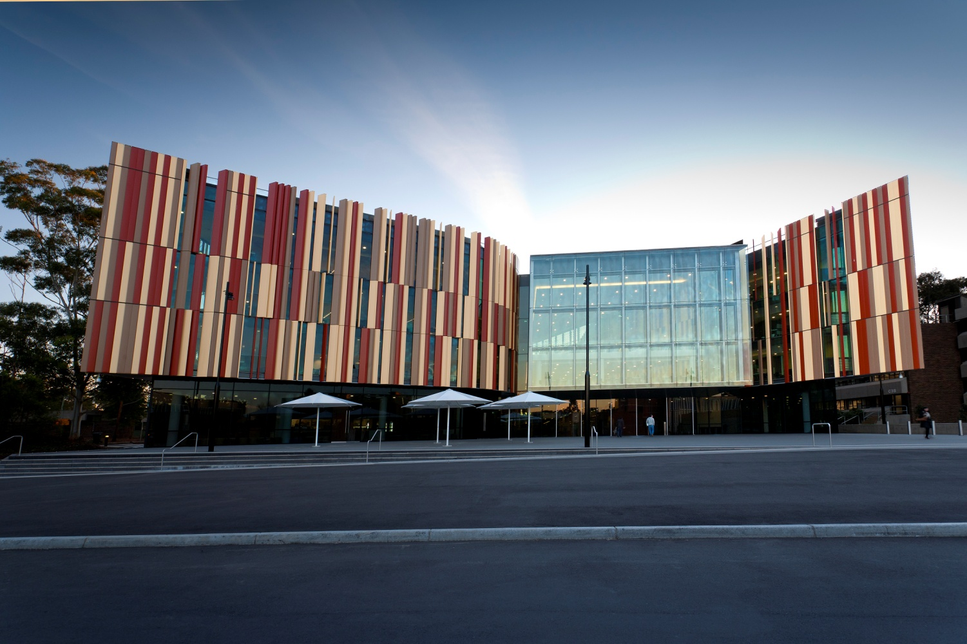Provide clear information on the Library website about their available support services available for students with disability.

Goal 3.4: University information is accessible: information published by the University will be equally accessible to people with disability.

***EXECUTIVE RESPONSIBILITY Office of the DVC and Chief Operating Officer*** *– Chief Information Officer;* ***Office of the DVC and Provost*** *– Manager, Macquarie University Accessibility Services*

***ASSISTING*** *Associate Deans (Learning and Teaching)*

**Actions**

* + 1. Ensure that all the University’s websites comply with international standards for access.
    2. Raise profile of Macquarie University Accessibility Services and Informatics as a source of assistance and support for continuous improvement in information accessibility.
    3. Develop and disseminate guidelines and links to resources for staff and students developing accessible print, photocopied, presentation (such as power point) and online materials.
    4. Expand the existing accessible e-Books project.

Goal 3.5: Right to Privacy will be protected for people with disability.

***EXECUTIVE RESPONSIBILITY Office of the DVC and Chief Operating Officer*** *– Chief Information Officer;* ***Office of the DVC and Provost*** *– Manager, Macquarie University Accessibility Services*

***ASSISTING*** *Associate Deans (Learning and Teaching)*

**Actions**

* + 1. Systems recording pertinent disability information are streamlined to prevent unnecessary duplication of questions relating to disability.

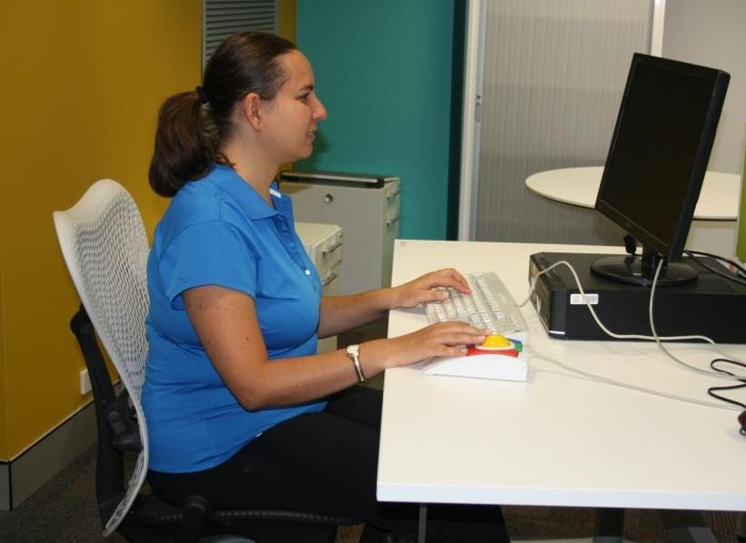

*Student Anne McCourt using a modified desk in the Higher Degree Research room in the Faculty of Arts*

Goal 3.6: Consultation mechanisms will be in place with people with disability, with ICT ‘user friendliness’ and stakeholder satisfaction monitored.

***EXECUTIVE RESPONSIBILITY Office of the DVC (Students and Registrar)*** *– Manager, Allied Health Services; Manager Clinical Operations (Disability)*

***ASSISTING*** *Chief Information Officer; Manager, Macquarie University Accessibility Services; Manager, Student Engagement*

**Actions**

* + 1. Mechanisms for consultation with stakeholders are established (through the Disability Service, Macquarie University Accessibility Services, MUSRA, MUPRA, broadcast emails, other mechanisms) to monitor accessibility needs and issues; user friendliness of systems; and stakeholder satisfaction.
    2. Investigate a communication mechanism to ensure that ICT jobs logged by staff with disability via One Help are addressed as for all staff.

SUCCESS INDICATORS Access to Information and Communications

1. Accessible ICT systems and processes are in place after user testing.
2. Increase in the number of academic staff approaching Macquarie University Accessibility Services for assistance.
3. Students and staff with disability report positively on the functioning of the Library (services and support).
4. Assistive technology is reviewed annually with students using the technology and industry partners.
5. Robust consultation mechanisms re ICT are in place and supporting materials developed eg guidelines for academic staff on appropriate use of ICT by students with disability are developed and reviewed annually.

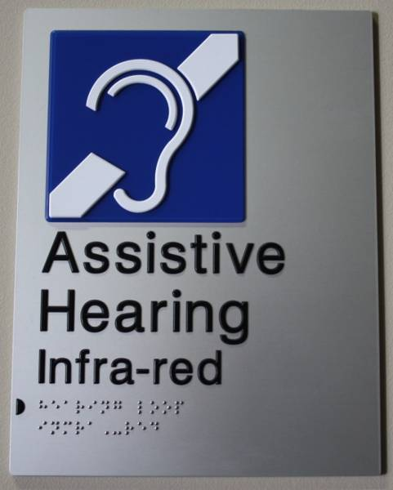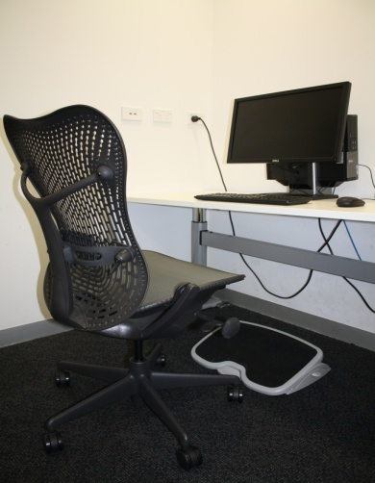

Accessible drinking fountain in the library
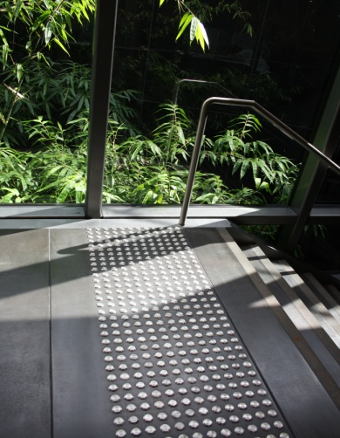

## Priority Area 4: Inclusive Physical Environment

***EXECUTIVE RESPONSIBILITY Office of the Vice Chancellor (****re: funding);* ***Office of the DVC and Chief Operating Officer*** *– Director, Property*

***ASSISTING*** *DAP Reference Group; Manager, Allied Health Services; Director, Equity and Diversity Unit*

Goal 4.1: Macquarie University will aspire to become a best practice model of an inclusive built environment, based on universal design principles.

**Actions**

* + 1. Engage leading edge experts in disability access to advise the University on proposed physical environment designs and consult with stakeholders regarding the user friendliness of design and development for people with disability.
    2. Meet or exceed the requirements of the DDA building code and relevant standards compliance for all new or refurbished areas of Macquarie University (teaching spaces and facilities).
    3. Demonstrate institutional commitment to maintaining and improving the physical environment for people with disability through specific funding allocations in the annual Capital Management Fund.

Goal 4.2: Macquarie University will aim to develop a physically ‘connected’ campus with identifiable improvements in physical accessibility for people with disability to, from and around campus.

**Actions**

* + 1. Enhance physical access “connectivity” across campus so it is coherent, continuous, direct and safe, and provides high amenity for people with mobility impairment.
    2. Undertake an initial, then scheduled, physical access audit and transport access audit (3-5 yearly) and use this evidence-based research to identify priorities for action (immediate, medium and long term).
    3. Improve and regularly update campus navigation systems both physical (eg signage, tactile markers, audio loops); and virtual (eg iPhone navigation apps, interactive maps/kiosks).
    4. Provide appropriate levels of accessible parking on university grounds (acquired and permanent disability) and ensure information on requirements and locations is readily available.

Goal 4.3: Institutional capacity around inclusive physical environment will become strong through the establishment of an Accessible Environments Advisory Group with an accompanying policy schedule to formally address physical access issues and enable communication and consultation with staff and student stakeholders.

**Actions**

* + 1. The Accessible Environments Advisory Group (AEAG) will provide advice and drive initiatives to improve campus responsiveness to disability issues related to built and physical environment, enhance information flow across internal agencies and provide an avenue for stakeholder consultation, for example:
* establish a communication process for notifying people with disability in a timely manner of changes to the built and physical environment
* clarify and communicate the processes, areas of responsibility and funding sources for physical workplace accommodations
* act as a conduit to a broader stakeholder constituency and provide formal feedback to the university eg on planning designs.

Goal 4.4: Staff and contractors will be aware of their responsibilities regarding the provision of a safe and inclusive physical environment for people with disability.

**Actions**

* + 1. Develop in-house expertise through providing professional development to key Macquarie Property staff on disability awareness and needs. This action is with a view to developing a designated role of ‘disability access advisor’ within Property (for expert advice and to act as a contact point on access issues) as well as strengthening overall workforce capacity.
    2. Provide information such that external contractors are aware of their responsibilities with regard to the built and physical environment.

SUCCESS INTORS Access to Information and Communications

SUCCESS INDICATORS Inclusive Physical Environment

1. Accessible Environments Advisory Group established including effective consultation mechanisms with people with disability with regard to the physical environment, barriers, improvements and physical connectivity.
2. Completion of a physical access audit of the University and a list of priorities for improvements identified (immediate, medium and long term).
3. An increase in the proportion of accessible buildings and facilities at the University.
4. Interactive campus navigation systems are developed and implemented including tactile markers, iPhone apps and interactive maps.
5. Physical access and universal design expertise explicit in Property staffing profile.

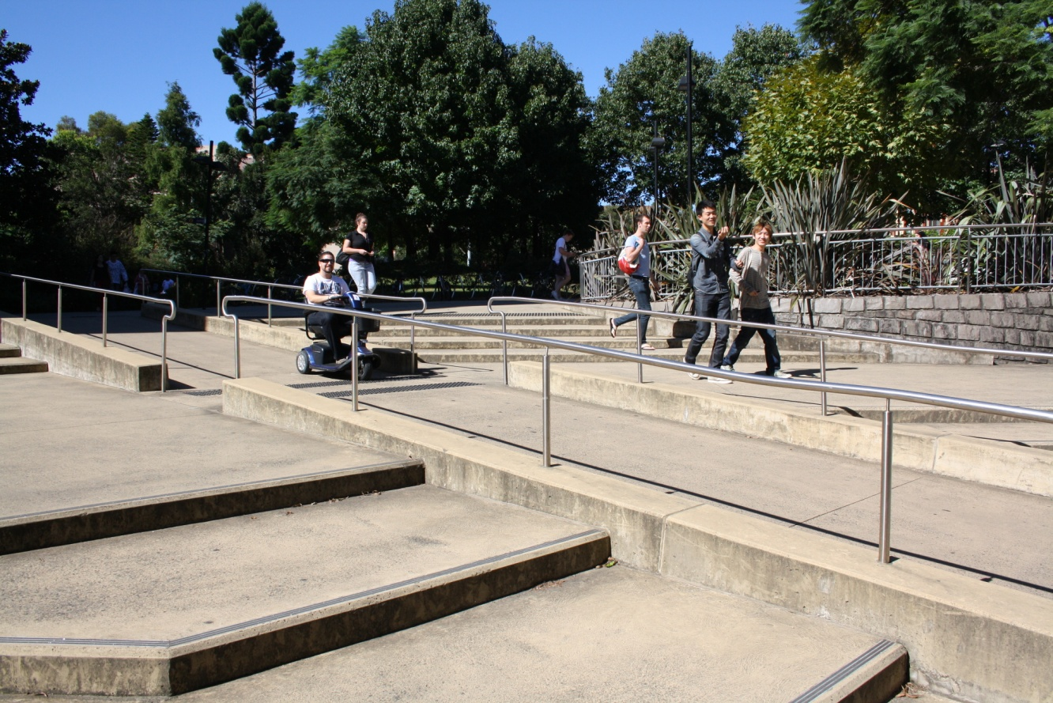

## Priority Area 5: Employment and Professional Development

***EXECUTIVE RESPONSIBILITY Director, Human Resources***

***ASSISTING*** *DAP Reference Group; Director, Equity and Diversity Unit*

Goal 5.1: Through an articulated Disability Employment Strategy, Macquarie University will aim to increase the number of people with disability employed by the university in accordance with the recommended government targets.

**Actions**

* + 1. Develop a phased, coherent and comprehensive employment strategy which addresses all stages of the institutional work-life cycle (marketing, recruitment, on-boarding, induction, retention, advancement) to attract people with disability to work at Macquarie.
    2. Establish a timely, coherent and centrally funded workplace accommodations process and communicate this to all staff.
    3. Collaborate between internal agencies in the development of the employment strategy (HR, faculties and offices, Equity and Diversity Unit, Research Office, Warawara - Department of Indigenous Studies; Campus Wellbeing and Support, Alumni Relations, Marketing).
    4. Provide feedback to HR on employment barriers in systems and processes (attraction, recruitment, retention and advancement) for people with disability and address these in a timely manner.
    5. Finalise and roll out a Mental Health Awareness Strategy for Macquarie staff that includes best practice in assisting managers and their staff in dealing with mental health conditions in the workplace.
    6. Provide a mechanism whereby staff with disability can give confidential online feedback to the University.

Goal 5.2: Mechanisms for identifying and matching candidates with disability with vacancies at the University will be improved and streamlined.

**Actions**

* + 1. Develop a Work Placements strategy for people with disability in line with the University’s Memorandum of Understanding with CRS Australia (signed December 2010) including voluntary placements, and the identification where possible of paid work opportunities at Macquarie on completion.
    2. Investigate the feasibility of introducing a traineeship or cadet program for people with disability at Macquarie.
    3. Ensure all recruitment advertising has positive messages and diverse images to encourage applications from people with disability (including reference to the DAP and reasonable workplace accommodations).
    4. Department of Human Services CRS Australia.
       Lucas (Rehabilitation Consultant); Bridget (Senior Rehabilitation Consultant); Sandi (Rehabilitation Consultant); Leon (Rehabilitation Consultant); Heidi (Regional Manager); Ali (Rehabilitation Consultant).
        

       Encourage alumni with disability to apply for positions at Macquarie.

*Department of Human Services CRS Australia L-R: Lucas (Rehabilitation Consultant); Bridget (Senior Rehabilitation Consultant); Sandi (Rehabilitation Consultant); Leon (Rehabilitation Consultant); Heidi (Regional Manager); Ali (Rehabilitation Consultant).*

Goal 5.3: Human Resource systems will be improved in order to gather robust data to increase knowledge of the Macquarie workforce profile in relation to staff with disability.

**Actions**

* + 1. Continually review, collect and analyse a suite of employment statistics for staff with disability; and maximise the capacity of the University systems to further improve data collection and analysis.
    2. Encourage and provide information and assistance to staff to enter and update their personal voluntary data on HR Online (eg during induction process or through targeted campaigning).
    3. Include relevant disability related questions about the employment experience at Macquarie in the biennial Your Say Staff Survey.
    4. Include disability statistics and recommendations in all Faculty Diversity Profiles and make equity recommendations to faculties and offices with regard to the employment of people with disabilities.

Goal 5.4: Macquarie employment related policy schedules (including advancement strategies such as reclassifications, promotion and professional development) will be continuously improved to ensure all are equitable, accessible and inclusive for existing and prospective employees with disability.

**Actions**

* + 1. Provide accessible recruitment processes for prospective staff and alternative application processes for people with disability as required for all advertised vacancies.
    2. Advise all shortlisted candidates at interview of the DAP and specify that workplace accommodations are available.
    3. Provide professional development for selection committee members in order that they are versed in equity principles; aware of legislative responsibilities regarding discrimination and workplace adjustments; are cognisant of the support available at Macquarie for managers and employees with disability, and able to relay this appropriately to applicants in the selection process.
    4. Provide assistance to fixed term and casual Macquarie staff candidates with disability when they apply for permanent positions at Macquarie (eg application writing and interview techniques) in order to build capacity.
    5. Review the University’s induction process to make it fully accessible (materials or information, processes, face to face advice, follow up) and include information on disability and support available to new staff.
    6. Ensure all centralised staff professional development activities are accessible and inclusive for staff with disability.
    7. Encourage retention of staff by providing information on support available at Macquarie (services, workplace accommodations) in the event of acquired temporary or permanent disability.
    8. Encourage staff with disability to participate in university decision making and governance (committees, working parties, steering groups).

**Sondra Wibberley, Disability Support Officer has been working at the University since 1992 and is Macquarie’s longest serving staff member with a disability.
**

*Sondra Wibberley, Disability Support Officer*

*Sondra has been working at the University since 1992 and is Macquarie’s longest serving staff member with a disability.*

Goal 5.5: The capacity of all staff will be strengthened in the area of disability (confidence and competence).

**Actions**

* + 1. Provision of staff professional development:
  1. Include disability specific information in professional development for managers (including the benefits of both the business case and the human rights case for employing people with disability, rights and responsibilities around flexible job design, building inclusive workplace culture, carers needs and reasonable adjustments legislation)
  2. Provide support to colleagues working with employees with disability as required in order to develop capacity and confidence (information, support and advice)
  3. Develop guidelines for creating a welcoming and inclusive work environment.

SSS CCESS INDICATORS Access to Information and Communications

SUCCESS INDICATORS Employment and Professional Development

1. A Macquarie University Disability Employment Strategy, based on robust data collection and analysis, is articulated and uploaded to the web.
2. Increased number of people with disability working at Macquarie in line with government targets and increased number of work placements for people with disability at Macquarie in line with the partnership with CRS Australia.
3. Recruitment and selection panels versed on disability issues, workplace accommodations scheme, legislative obligations.
4. Professional development and assistance available for all Macquarie staff with regard to working with, managing and supervising people with disability.
5. Disability related information embedded in HR documentation for new and existing staff including guidelines for creating a welcoming and inclusive work environment (for all staff).

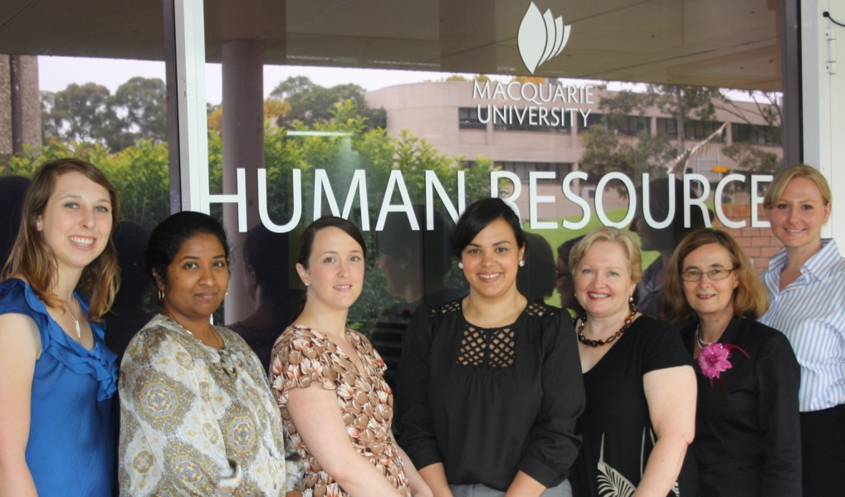

## Priority Area 6: Campus Community

*Human Resources Recruitment Team L-R: Anne Sedgley, Anne Kumanan, Lisa Warren, Melissa Mesiti, Sally Matthey (Manager, Strategic Resourcing and Talent), Patsy Moss, Lyndal Watt*

Goal 6.1: The University will continue to foster an inclusive campus culture where staff and students are aware, sensitive and responsive to the needs of people with disability, and where diversity is valued and celebrated, and where discrimination and harassment are not tolerated.

***SHARED EXECUTIVE RESPONSIBILITY Senior Executive****;* ***Office of the DVC (Students and Registrar) –*** *Director, Campus Life; Director, Campus Wellbeing and Support*

***EXECUTIVE RESPONSIBILITY FOR CAMPUS SAFETY PLAN Director, Human Resources*** *–**Manager, Health and Safety;* ***Director, Property*** *– Campus Security Manager*

**Actions**

**To increase general awareness:**

* + 1. In collaboration with MUSRA, MUPRA, Equity and Diversity Unit and Campus Wellbeing and Support, incorporate disability-focused events throughout the year including two high profile public events for staff and students supporting national disability initiatives.
    2. Explicitly consider disability in Staff Engagement Working Party deliberations.
    3. Provide disability specific information and services into all events and initiatives.

**To foster a welcoming and inclusive environment for people with disability:**

* + 1. Make all university public relations, marketing and promotional materials (hard and soft copy materials) available in accessible format.
    2. Feature diverse images of staff and students in university publications and regularly promote the achievements of staff and students with disability.
    3. Ensure all university events are inclusive in design, promotion and implementation.
    4. Sustainability initiatives will be inclusive for people with disability.

**To increase responsiveness:**

* + 1. Promote Campus Wellbeing and Support both internally and in outreach activities.
    2. Represent the range of disability services offered by Macquarie at all university promotional events such as Open Day, Parents Nights etc.
    3. Provide students with the profiles of staff who have knowledge and skills to assist students with disability.
    4. Educate staff and students on the university’s legislative requirements and the Macquarie grievance policy schedule.
    5. Conduct specific training for security staff on managing critical incidents involving people with disability, especially mental health conditions.

**To increase awareness of international students with disability:**

* + 1. Provide information on disability support services to all international students pre-departure, including mental health information and support available.
    2. Conduct focus groups with international students to determine their understanding of disability support services in order to inform practice.
    3. Investigate the feasibility of childcare scholarships for international research students with disability.
    4. Provide accessible accommodation on campus for students with disability and alert students with disability living on campus of appropriate after hours support.
    5. Seek regular formal feedback from staff and students with disability on all aspects of University life and use this feedback to continuously improve Macquarie practice.
    6. Encourage Macquarie affiliates to work within the principles of inclusion that underpin the Macquarie DAP.
    7. Roll out the Campus Safety Plan and promote it to all staff and students.

Goal 6.2: The non-academic environment of the university will be inclusive and enable the equitable participation of people with disability.

***EXECUTIVE RESPONSIBILITY Office of the DVC (Students and Registrar) –*** *Manager, Student Engagement;* ***Director of Marketing***

***ASSISTING*** *DAP Reference Group*

**Actions**

* + 1. Annually monitor student engagement activities and student group membership and terms of reference (MUSRA, MUPRA, faculties, Macquarie University Sport and Aquatic Centre (MUSAC)) to make sure they inclusive for students with disability.
    2. Ensure all university wide community engagement activities (eg Campus Life, ‘S.A.L.T.’ project, community garden) are inclusive and allow the participation of all interested students.
    3. Align any corporate marketing campaigns targeting students or external advertising on campus endorsed by the University with the principles of equity and inclusion.

Goal 6.3: University facilities and services will be inclusive and enable the equitable participation of all people.

***EXECUTIVE RESPONSIBILITY Office of the DVC (Students and Registrar)*** *– Director, Campus Life*

***ASSISTING*** *DAP Reference Group; Director, Equity and Diversity Unit*

**Actions**

* + 1. Deliver a range of products and services appropriate to people with disability on campus, and consider in a timely manner feedback received from stakeholders on improvements to service provision in retail outlets, food and beverage etc.
    2. Provide accessible retail outlets and check outs on campus and consider the implications for people with disability in any relocations or refurbishments on campus in line with the DDA.
    3. Continuously improve the accessibility and inclusiveness of MUSAC, Sport Fields and Sport and Recreation programs for people with disability, and investigate ways of further encouraging usage eg buddy systems, free entry for carers, sports exhibitions involving people with disability.
    4. Provide Auslan interpreters and/or captioning at Macquarie events (as regular practice and/or on request) and advise Macquarie staff on the role of the interpreter.
    5. Investigate childcare scholarships or grants for students with disability and continue to meet the Department of Community Services compliance requirements for priority of access to families and children with disability.

SUCCESS INDICATORS Campus Community

1. Disability focused events are included in the Macquarie calendar including two high profile annual events supporting national disability initiatives.
2. Campus services are fully accessible to people with disability.
3. Information about the disability services available on campus is included in all University promotional events eg Open Day, Parents Night.
4. Annual focus groups are conducted with international students to assess their knowledge of disability and improve service and information delivery.
5. Tailored disability services are provided to students from culturally and linguistically diverse (CALD) groups utilizing staff who speak the language of the target group.
6. Campus Safety Plan is implemented.

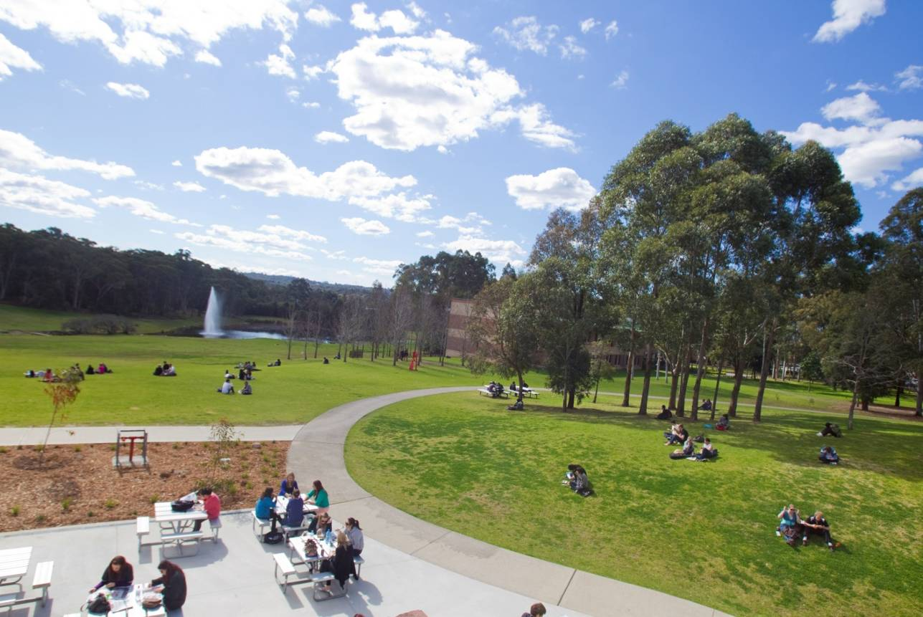

# Appendices/Statistics

## Disability at Macquarie: a STUDENT Snapshot

###### Table 1: Students with Disability by Faculty, 2007 – 2011

| Faculty / Area | Year | All students | All Students with disability | | Students in equity scope | Students with disability (equity scope) | |
| --- | --- | --- | --- | --- | --- | --- | --- |
|  |  | **No.** | **No.** | **%** | **No.** | **No.** | **%** |
| **Arts** | 2007 | 5571 | 265 | 4.8% | 4869 | 253 | 5.2% |
| 2008 | 5659 | 243 | 4.3% | 4912 | 237 | 4.8% |
| 2009 | 6341 | 269 | 4.2% | 5629 | 266 | 4.7% |
| 2010 | 6965 | 304 | 4.4% | 6215 | 300 | 4.8% |
| 2011 | 7100 | 338 | 4.8% | 6072 | 308 | 5.1% |
| **Business and Economics** | 2007 | 12955 | 184 | 1.4% | 6030 | 147 | 2.4% |
| 2008 | 13405 | 156 | 1.2% | 6111 | 137 | 2.2% |
| 2009 | 14931 | 169 | 1.1% | 6591 | 156 | 2.4% |
| 2010 | 15924 | 170 | 1.1% | 6719 | 151 | 2.2% |
| 2011 | 16018 | 170 | 1.1% | 6621 | 145 | 2.2% |
| **Human Sciences** | 2007 | 5520 | 223 | 4.0% | 4326 | 219 | 5.1% |
| 2008 | 5451 | 206 | 3.8% | 4381 | 204 | 4.7% |
| 2009 | 5639 | 232 | 4.1% | 4641 | 228 | 4.9% |
| 2010 | 6060 | 255 | 4.2% | 5078 | 247 | 4.9% |
| 2011 | 6267 | 278 | 4.4% | 5091 | 252 | 4.9% |
| **Science** | 2007 | 4002 | 145 | 3.6% | 3238 | 133 | 4.1% |
| 2008 | 4044 | 144 | 3.6% | 3241 | 134 | 4.1% |
| 2009 | 4186 | 154 | 3.7% | 3418 | 145 | 4.2% |
| 2010 | 4540 | 184 | 4.1% | 3731 | 172 | 4.6% |
| 2011 | 4829 | 181 | 3.7% | 3829 | 159 | 4.2% |
| **MGSM** | 2007 | 2123 | 12 | 0.6% | 1384 | 9 | 0.7% |
| 2008 | 2177 | 10 | 0.5% | 1403 | 8 | 0.6% |
| 2009 | 2061 | 15 | 0.7% | 1343 | 14 | 1.0% |
| 2010 | 1869 | 15 | 0.8% | 1289 | 13 | 1.0% |
| 2011 | 1697 | 11 | 0.6% | 1076 | 9 | 0.8% |
| **Other courses** | 2007 | 1997 | 41 | 2.1% | 654 | 32 | 4.9% |
| 2008 | 1738 | 39 | 2.2% | 550 | 32 | 5.8% |
| 2009 | 1432 | 32 | 2.2% | 482 | 23 | 4.8% |
| 2010 | 1315 | 35 | 2.7% | 497 | 24 | 4.8% |
| 2011 | 1223 | 41 | 3.3% | 474 | 26 | 5.5% |
| **TOTAL** | 2007 | 32168 | 870 | 2.70% | 20501 | 793 | 3.87% |
| 2008 | 32474 | 798 | 2.46% | 20598 | 752 | 3.65% |
| 2009 | 34590 | 871 | 2.52% | 22104 | 832 | 3.76% |
| 2010 | 36673 | 963 | 2.63% | 23529 | 907 | 3.85% |
| 2011 | 37134 | 1019 | 2.74% | 23163 | 899 | 3.88% |

* Disability data is self-reported.
* The ‘Macquarie University’ category includes cross institutional students and students undertaking non Award courses.
* ‘In equity scope’ does not include International students; students with home address outside Australia and cross institutional students.
* In the overall student body, there were 964 students (2.6%) in 2010 and 1020 (2.7%) in 2011 who reported having disability. Of the domestic students undertaking an award course, there were 908 (3.8%) in 2010 and 900 (3.9%) in 2011 who reported having disability.

###### Table 2: Macquarie Disability Service: Total Estimate of Students Registering with the Disability Service by Faculty 2011

| **Macquarie Faculty** | **Estimated Number of**  **Disability Service Student Registrations** | **Estimated Percentage of**  **Disability Service Student Registrations** |
| --- | --- | --- |
| **Arts** | 277 | 29.3% |
| **Business and Economics** | 132 | 13.9% |
| **Human Sciences** | 217 | 22.9% |
| **Science** | 139 | 14.7% |
| **Unspecified** | 182 | 19.2% |
| **Total** | 947 | 100% |

###### Table 3: Disability Service Registered Students by Year 2006 – 2012 (2012 estimations)

| **Students registered** | **2006** | **2007** | **2008** | **2009** | **2010** | **2011** | **2012** |
| --- | --- | --- | --- | --- | --- | --- | --- |
| Number of students | 429 | 435 | 484 | 619 | 820 | 947 | 1200 (est) |
| % growth | n/a | 1.4% | 11% | 28% | 33% | 16% | 27% |

###### Table 4: Student Disability Types (self-reported from Enrolment data) 2007 - 2011 [5]

| **Year** | **Hearing** | | **Learning** | | **Mobility** | | **Visual** | | **Medical** | | **Other** | | **Support** | | **TOTAL** | |
| --- | --- | --- | --- | --- | --- | --- | --- | --- | --- | --- | --- | --- | --- | --- | --- | --- |
|  | **All** | **In EQ scope** | **All** | **In EQ scope** | **All** | **In EQ scope** | **All** | **In EQ scope** | **All** | **In EQ scope** | **All** | **In EQ scope** | **All** | **In EQ scope** | **All** | **In EQ scope** |
| **2007** | 70 | 66 | 129 | 107 | 117 | 112 | 175 | 151 | 346 | 321 | 160 | 152 | 337 | 283 | 1334 | 1192 |
| **2008** | 52 | 52 | 127 | 110 | 100 | 98 | 134 | 128 | 321 | 301 | 189 | 181 | 285 | 266 | 1208 | 1136 |
| **2009** | 56 | 54 | 138 | 128 | 92 | 88 | 121 | 118 | 386 | 371 | 223 | 211 | 326 | 309 | 1342 | 1279 |
| **2010** | 47 | 43 | 147 | 134 | 94 | 93 | 125 | 118 | 442 | 419 | 262 | 251 | 350 | 335 | 1467 | 1393 |
| **2011** | 43 | 41 | 139 | 129 | 90 | 89 | 94 | 89 | 482 | 463 | 267 | 259 | 330 | 323 | 1445 | 1393 |

###### Table 5: Students with Disability registered with the Macquarie Disability Service by gender 2007 - 2011

| **Students** | **2007** | | | **2008** | | | **2009** | | | **2010** | | | **2011** | | |
| --- | --- | --- | --- | --- | --- | --- | --- | --- | --- | --- | --- | --- | --- | --- | --- |
| **Number of students** | 435 | | | 484 | | | 619 | | | 820 | | | 947 | | |
| **% annual increase** | - | | | 11% | | | 28% | | | 33% | | | 16% | | |
| **Gender** | F | M | Unsp | F | M | Unsp | F | M | Unsp | F | M | Unsp | F | M | Unsp |
| **Number** | 256 | 178 | 1 | 292 | 190 | 2 | 369 | 239 | 8 | 452 | 348 | 0 | 522 | 281 | 144 |
| **% of total** | 59% | 41% | 0.2% | 60% | 39% | 0.5% | 60% | 39% | 1% | 56.5 | 43.5 | 0.0% | 55% | 30% | 15% |

###### Table 6: Students registered with the Macquarie Disability Service by Disability Type 2007 – 2011

| **Year** | **Vision** | **Hearing** | **Deaf** | **Speech** | **Physical** | **Head Injury** | **Mental Health** | **Learning\*** | **Chronic Medical** | **Temporary** | **Other** | **Unspecified** | **TOTAL** |
| --- | --- | --- | --- | --- | --- | --- | --- | --- | --- | --- | --- | --- | --- |
| **2007** | 23 | 12 | 5 | 3 | 102 | 16 | 91 | 100 | 102 | - | 21 | - | 475 |
| **2008** | 25 | 15 | 2 | 1 | 104 | 10 | 122 | 112 | 94 | - | 32 | - | 517 |
| **2009** | 21 | 31 | 5 | 1 | 107 | 11 | 197 | 138 | 106 | - | 37 | - | 654 |
| **2010** | 30 | 39 | 8 | 1 | 167 | - | 291 | 184 | 154 | - | 63 | - | 820 |
| **2011** | 32 | 22 | 4 | 0 | 129 | 19 | 298 | 130 | 161 | 28 | 6 | 118 | 947 |
| **% increase since 2007** | 39% | 83% | -20% | -100% | 27% | 19% | 227% | 30% | 58% | - | -71% | - | 99% |

* ‘Learning’ inc. students with Asperger’s Syndrome and Dyslexia (numbers of both increasing). The Service commenced differentiating these disabilities from 2010 on advice from NSW Dept of Education.

###### Table 7: Students registered with the Macquarie Disability Service by Disability Type by Faculty 2011

| **Faculty** | **Vision** | **Hearing** | **Deaf** | **Speech** | **Physical** | **Mental Health** | **Learning** | **Temporary** | **Chronic medical** | **Aspergers** | **Dyslexia** | **Other disability** | **TOTAL** |
| --- | --- | --- | --- | --- | --- | --- | --- | --- | --- | --- | --- | --- | --- |
| **Arts** | 14 | 14 | 1 | 38 | 6 | 106 | 41 | 3 | 57 | 7 | 5 | 2 | **294** |
| **Business and Economics** | 4 | 0 | 1 | 34 | 4 | 40 | 19 | 10 | 16 | 1 | 0 | 2 | **131** |
| **Human Sciences** | 5 | 2 | 1 | 37 | 3 | 81 | 24 | 9 | 47 | 0 | 5 | 1 | **215** |
| **Science** | 2 | 4 | 0 | 19 | 4 | 38 | 37 | 3 | 27 | 1 | 1 | 1 | **137** |
| **Unknown Faculty** | 7 | 1 | 1 | 11 | 2 | 22 | 9 | 3 | 14 | 0 | 1 | 0 | **71** |
| **Total** | **32** | **21** | **4** | **139** | **19** | **287** | **130** | **28** | **161** | **9** | **12** | **6** | **848** |

###### Table 8: Students registered with the Macquarie Disability Service 2007 – 2011 presenting with mental illness and 2011 estimates

| **Students registered** | **2007** | **2008** | **2009** | **2010** | **2011** |
| --- | --- | --- | --- | --- | --- |
| **Students with a mental illness** | 91 | 122 | 197 | 291 | 298 |
| **% annual increase** | n/a | 28% | 61% | 48% | 2% |

## People with Disability at Macquarie: a STAFF Snapshot[6]

###### Table 9: Staff with Disability as a proportion of all respondents 2007 – 2011 (as at 31 March each year)

| **Year** | **2007** | | **2008** | | **2009** | | **2010** | | **2011** | | **2007** | | **2008** | | **2009** | | **2010** | | **2011** | |
| --- | --- | --- | --- | --- | --- | --- | --- | --- | --- | --- | --- | --- | --- | --- | --- | --- | --- | --- | --- | --- |
|  | **No.** | | **No.** | | **No** | | **No.** | | **No.** | | **%** | | **%** | | **%** | | **%** | | **No** | |
| **Staff Type** | **All** | **PWD** | **All** | **PWD** | **All** | **PWD** | **All** | **PWD** | **All** | **PWD** | **Other** | **PWD** | **Other** | **PWD** | **Other** | **PWD** | **Other** | **PWD** | **Other** | **PWD** |
| **Academic No.** | 647 | 41 | 720 | 34 | 605 | 30 | 676 | 33 | 662 | 31 | 93.7% | 6.3% | 95.3% | 4.7% | 95.2% | 4.8% | 95.1% | 4.9% | 95.3% | 4.7% |
| **Professional No.** | 649 | 43 | 792 | 45 | 755 | 37 | 800 | 33 | 738 | 31 | 93.4% | 6.6% | 94.3% | 5.7% | 95.1% | 4.9% | 95.9% | 4.1% | 95.8% | 4.2% |
| **Total** | **1296** | **84** | **1512** | **79** | **1360** | **67** | **1476** | **66** | **1400** | **62** | **93.5%** | **6.5%** | **94.8%** | **5.2%** | **95.1%** | **4.9%** | **95.5%** | **4.5%** | **95.6%** | **4.4%** |

###### Table 10: Academic Staff with Disability by Level as a % of Academic Staff who responded at each level 2007 – 2011 (as at 31 March each year)

| **Year** | **2007** | | **2008** | | **2009** | | **2010** | | **2011** | | **2007** | | **2008** | | **2009** | | **2010** | | **2011** | | |
| --- | --- | --- | --- | --- | --- | --- | --- | --- | --- | --- | --- | --- | --- | --- | --- | --- | --- | --- | --- | --- | --- |
|  | **No.** | | **No.** | | **No.** | | **No.** | | **No.** | | **%** | | **%** | | **%** | | **%** | | **%** | | |
| **Level** | **All** | **PWD** | **All** | **PWD** | **All** | **PWD** | **All** | **PWD** | **All** | **PWD** | **Other** | **PWD** | **Other** | **PWD** | **Other** | **PWD** | **Other** | **PWD** | **Other** | **PWD** |
| A | 68 | 4 | 101 | 5 | 76 | 5 | 91 | 4 | 67 | 4 | 94.1% | 5.9% | 95.0% | 5.0% | 93.6% | 6.4% | 95.6% | 4.4% | 94.0% | 6.0% |
| B | 181 | 9 | 198 | 6 | 154 | 4 | 162 | 4 | 155 | 4 | 95.0% | 5.0% | 97.0% | 3.0% | 97.7% | 2.3% | 97.5% | 2.5% | 97.4% | 2.6% |
| C | 180 | 17 | 195 | 13 | 174 | 12 | 187 | 15 | 180 | 14 | 90.6% | 9.4% | 93.3% | 6.7% | 92.9% | 7.1% | 92.0% | 8.0% | 92.3% | 7.7% |
| D | 117 | 6 | 121 | 5 | 113 | 5 | 134 | 6 | 131 | 4 | 94.9% | 5.1% | 95.9% | 4.1% | 95.6% | 4.4% | 95.5% | 4.5% | 96.9% | 3.1% |
| E | 101 | 5 | 105 | 5 | 89 | 5 | 102 | 4 | 129 | 8 | 95.0% | 5.0% | 95.2% | 4.8% | 69% | 5.0% | 96.1% | 3.9% | 93.8% | 6.2% |
| **TOTAL** | **647** | **41** | **720** | **34** | **605** | **30** | **676** | **33** | **662** | **31** | **93.7%** | **6.3%** | **95.3%** | **4.7%** | **94.7%** | **5.3%** | **95.1%** | **4.9%** | **95.3%** | **4.7%** |

###### Table 11: Professional Staff with Disability by HEW Level as a % of Professional Staff who responded at each HEW Level 2007 – 2011 (as at 31 March each year)

|  |  |  |  |  |  |  |  |  |  |  |  |  |  |  |  |  |  |  |  |  |
| --- | --- | --- | --- | --- | --- | --- | --- | --- | --- | --- | --- | --- | --- | --- | --- | --- | --- | --- | --- | --- |
| Year | 2007 | | 2008 | | 2009 | | 2010 | | 2011 | | 2007 | | 2008 | | 2009 | | 2010 | | 2011 | |
|  | **No.** | | **No.** | | **No.** | | **No.** | | **No.** | | **%** | | **%** | | **%** | | **%** | | **%** | |
| **Level** | **All** | **PWD** | **All** | **PWD** | **All** | **PWD** | **All** | **PWD** | **All** | **PWD** | **Other** | **PWD** | **Other** | **PWD** | **Other** | **PWD** | **Other** | **PWD** | **Other** | **PWD** |
| **1** | 1 | 1 | 2 | 1 | 1 | 1 | 1 | 1 | 1 | 1 | 0.0% | 100% | 50.0% | 50.0% | 44% | 56% | 0% | 100% | 0% | 100% |
| **2** | 15 | 1 | 8 | 2 | 7 | 2 | 13 | 3 | 9 | 2 | 93.3% | 6.7% | 75.0% | 25.0% | 61.1% | 28.9% | 76.9% | 23.1% | 77.8% | 22.2% |
| **3** | 21 | 1 | 31 | 2 | 24 | 0 | 24 | 0 | 18 | 1 | 95.2% | 4.8% | 93.5% | 6.5% | 98.2% | 1.8% | 100% | 0.0% | 94.4% | 5.6% |
| **4** | 57 | 2 | 67 | 3 | 52 | 1 | 44 | 1 | 40 | 1 | 96.5% | 3.5% | 95.5% | 4.5% | 98.1% | 1.9% | 97.7% | 2.3% | 97.5% | 2.5% |
| **5** | 103 | 9 | 139 | 10 | 111 | 8 | 116 | 5 | 106 | 5 | 91.3% | 8.7% | 92.8% | 7.2% | 92.4% | 7.6% | 95.7% | 4.3% | 95.3% | 4.7% |
| **6** | 138 | 10 | 175 | 7 | 194 | 8 | 205 | 10 | 183 | 8 | 92.8% | 7.2% | 96.0% | 4.0% | 95.6% | 4.4% | 95.1% | 4.9% | 95.6% | 4.4% |
| **7** | 121 | 3 | 148 | 4 | 151 | 3 | 163 | 4 | 161 | 5 | 97.5% | 2.5% | 97.3% | 2.7% | 97.7% | 2.3% | 97.4% | 2.6% | 96.9% | 3.1% |
| **8** | 77 | 7 | 92 | 6 | 80 | 4 | 85 | 2 | 77 | 1 | 90.9% | 9.1% | 93.5% | 6.5% | 95% | 5.0% | 97.6% | 2.4% | 98.7% | 1.3% |
| **9** | 57 | 2 | 64 | 1 | 74 | 1 | 84 | 1 | 87 | 3 | 96.5% | 3.5% | 98.4% | 1.6% | 98.6% | 1.4% | 98.8% | 1.2% | 96.5% | 3.5% |
| **10 +** | 59 | 7 | 66 | 9 | 61 | 8 | 65 | 6 | 56 | 4 | 88.1% | 11.9% | 86.4% | 13.6% | 86.9% | 13.1% | 90.8% | 9.2% | 92.9% | 7.1% |
| **TOTAL** | **649** | **43** | **792** | **45** | **755** | **37** | **800** | **33** | **738** | **31** | **93.4%** | **6.6%** | **94.3%** | **5.7%** | **95.1%** | **4.9%** | **95.9%** | **4.1%** | **95.8%** | **4.2%** |



Balaclava Road, North Ryde, Sydney, Australia

Telephone (02) 9850 7111 Facsimile (02) 9850 7433

Macquarie University CRICOS Provider Number 00002J

[www.mq.edu.au](http://www.mq.edu.au)

1. <http://www.hreoc.gov.au/disability_rights/dda_guide/getting_/getting_.html>
2. . There are increasing numbers of students with disability entering Macquarie through the OUA pathway. The support needs of these students are to be met by Macquarie and they are included in DSU data collection. They are not, however, included in the numbers reported by Macquarie to DEEWR as OUA reports directly on behalf of partner universities.
3. Exam provisions were the most significant issue of concern expressed by stakeholders during the DAP consultations
4. Unit/course evaluation feedback is currently (2012) monitored and collated by LTC and reported to individual teachers, with Unit feedback communicated to Assoc Deans (L& T). Feedback on disability related issues could be used more broadly to inform institutional improvement.
5. Individual figures do not add to totals, due to some students having multiple disabilities; ‘In equity scope’ does not include International students; students with home address outside Australia and cross institutional students.
6. Staff Data is gathered via a voluntary process (‘All Respondents’ indicates those who have completed the voluntary online data survey).